**How to Drive a DC Motor**

**using RASPBERRY PI 3 GPIO**

**Output:**

[**https://photos.app.goo.gl/L7e6PjzZoVPz2Nu58**](https://photos.app.goo.gl/L7e6PjzZoVPz2Nu58)

**Objective :**

The main objective is to drive a DC motor using the Power Supply Module to supply motors. We achieve this with Python programming using the Raspberry Pi 3 model B development board.

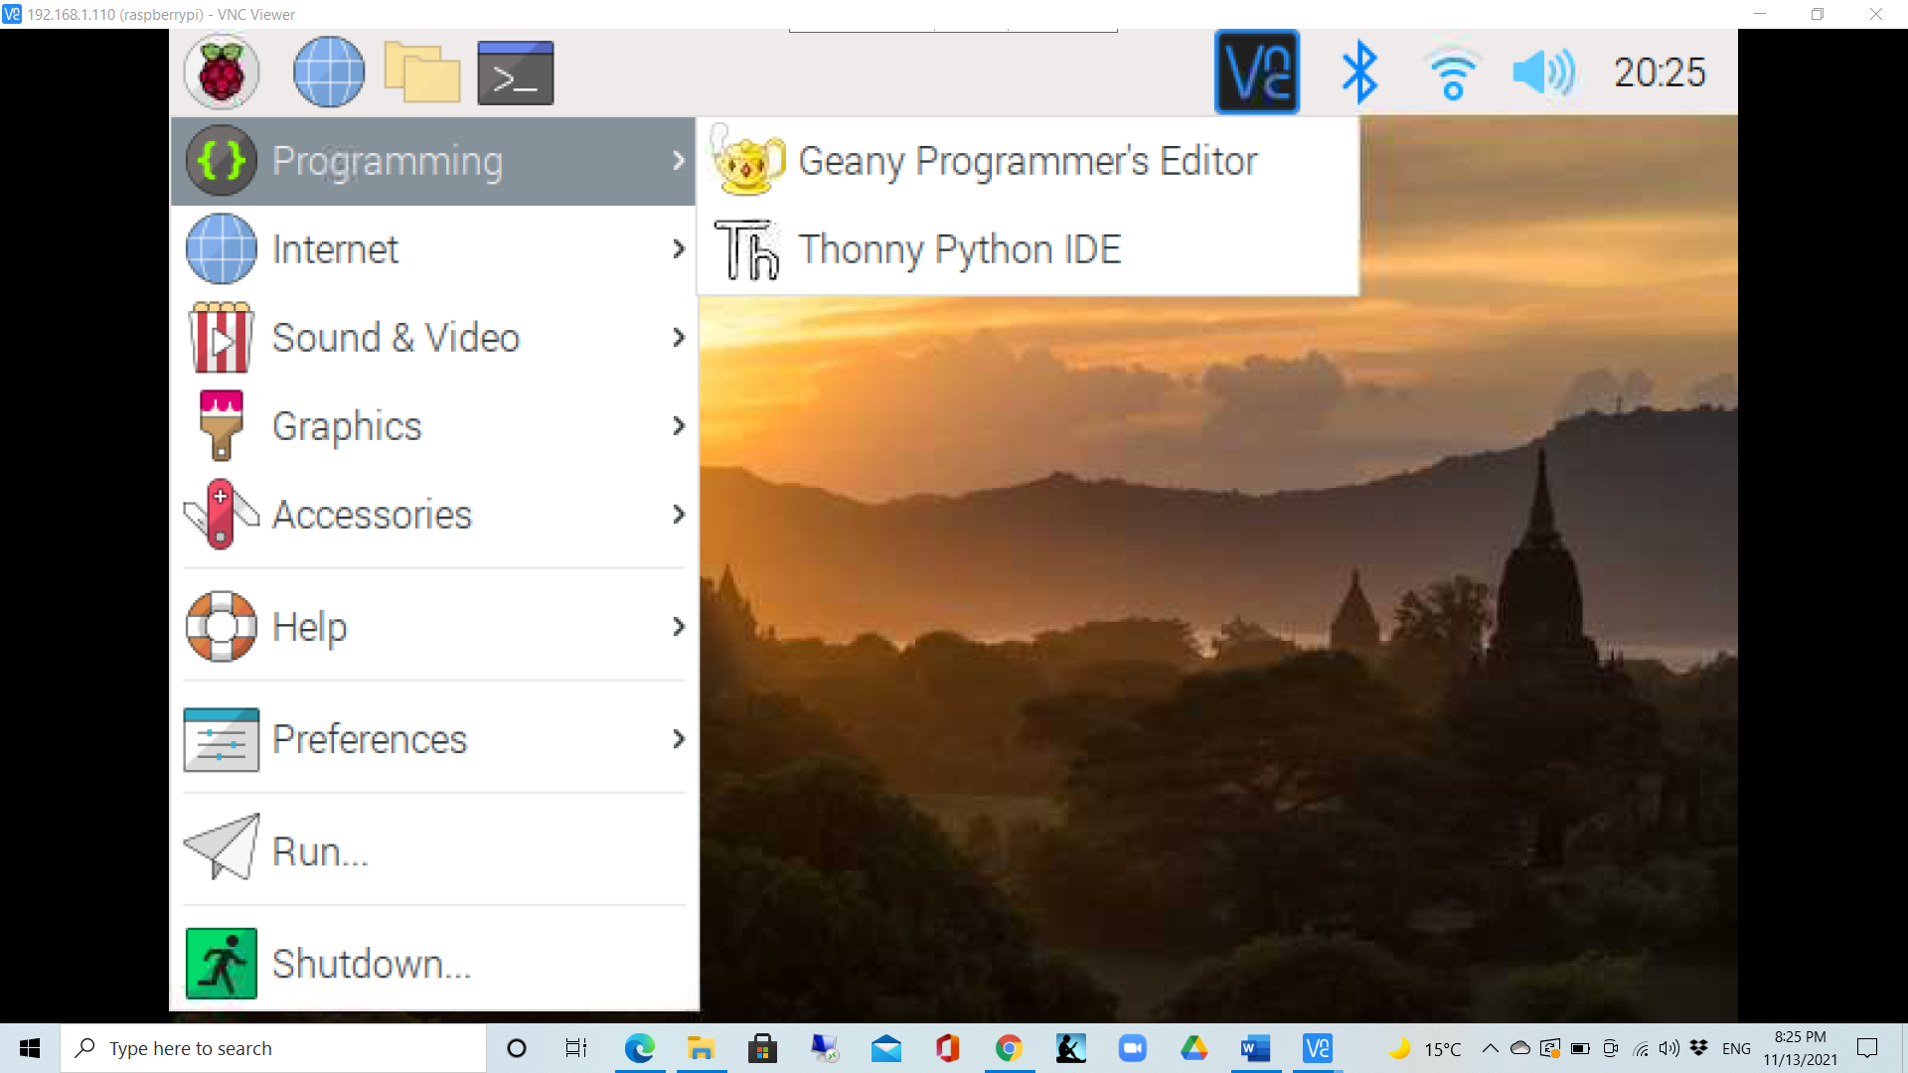

**Components:**

* Raspberry Pi
* Breadboard
* L293D
* DC Motor
* Power Module
* Jumper wires

**Connections**:

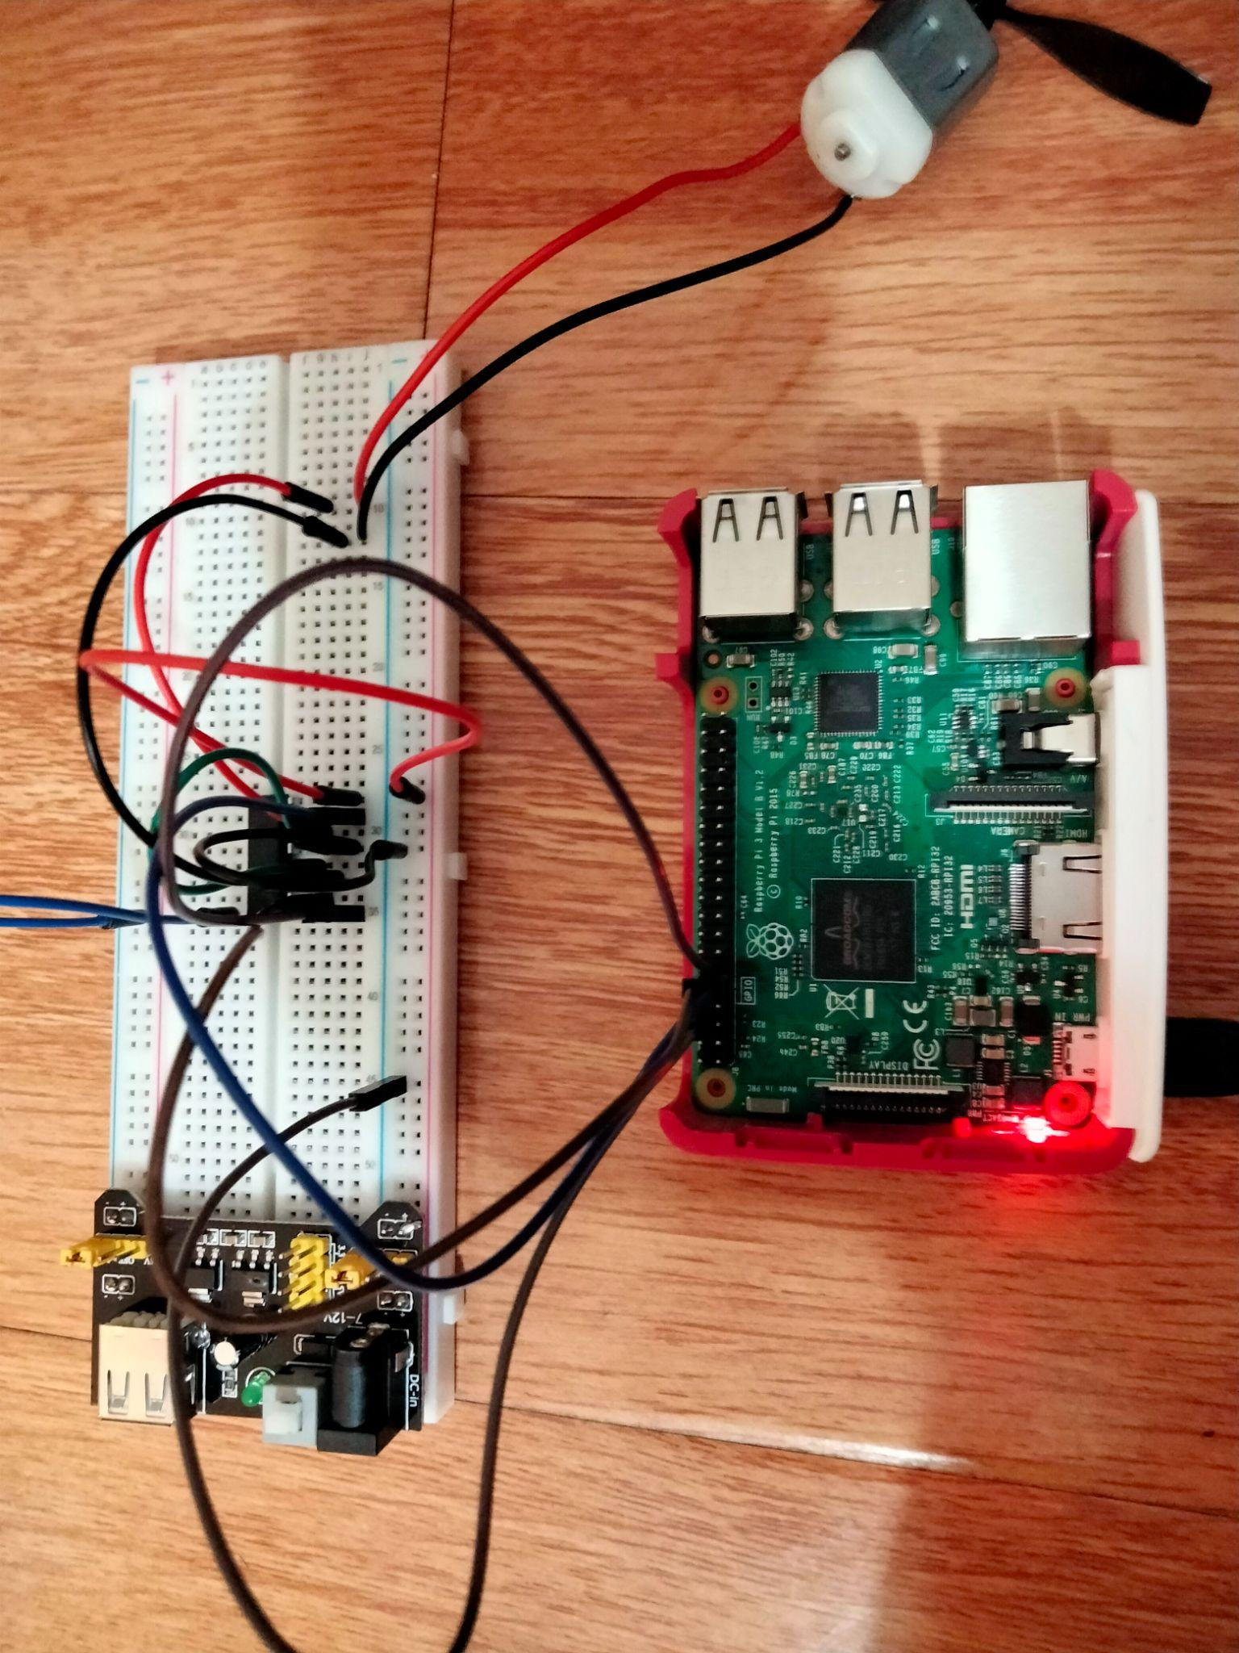

**Working:**

Once the wireless connection is established then open thonny Python IDE.

1. Type in the program and save as DC_Motor.py

**# Python Program**

import RPi.GPIO as GPIO

import time

MotorPin1 = 11 # pin11

MotorPin2 = 12 # pin12

MotorEnable = 13 # pin13

def setup():

GPIO.setmode(GPIO.BOARD) # Numbers GPIOs by physical location

GPIO.setup(MotorPin1, GPIO.OUT) # mode --- output

GPIO.setup(MotorPin2, GPIO.OUT)

GPIO.setup(MotorEnable, GPIO.OUT)

GPIO.output(MotorEnable, GPIO.LOW) # motor stop

def loop():

while True:

print 'Press Ctrl+C to end the program...'

GPIO.output(MotorEnable, GPIO.HIGH) # motor driver enable

GPIO.output(MotorPin1, GPIO.HIGH) # clockwise

GPIO.output(MotorPin2, GPIO.LOW)

time.sleep(5)

GPIO.output(MotorEnable, GPIO.LOW) # motor stop

time.sleep(5)

GPIO.output(MotorEnable, GPIO.HIGH) # motor driver enable

GPIO.output(MotorPin1, GPIO.LOW) # anticlockwise

GPIO.output(MotorPin2, GPIO.HIGH)

time.sleep(5)

GPIO.output(MotorEnable, GPIO.LOW) # motor stop

time.sleep(5)

def destroy():

GPIO.output(MotorEnable, GPIO.LOW) # motor stop

GPIO.cleanup() # Release resource

setup()

try:

loop()

except KeyboardInterrupt: # When 'Ctrl+C' is pressed, the child program destroy() will be executed.

destroy()

1. Run the program in command prompt as:

sudo python DC_Motor.py

1. Turn on the power module .
2. Check the DC motor.